**MAULANA AZAD**

**NATIONAL INSTITUTE OF TECHNOLOGY**

**BHOPALINDIA, 462003**



**DEPARTMENT OF COMPUTER SCIENCE & ENGINEERING**

**CLASSIFICATION OF MENTAL STATES USING 1-D CNN**

**Minor Project Report**

**Semester - 5**

**Submitted by:**

**SAUHARD PAREEK 191112237**

**SAMYAK MEHTA 191112213**

**CHEERLA SAI KRUSHEEL 191112259**

**KRISHNA KANT GOYAL 191112275**

**Under the Guidance of**

**Dr. MITUL KUMAR AHIRWAL**

## DEPARTMENT OF COMPUTER SCIENCE AND ENGINEERING

**Session: 2019-23**

**MAULANA AZAD**

**NATIONAL INSTITUTE OF TECHNOLOGY**

**BHOPALINDIA, 462003**



**DEPARTMENT OF COMPUTER SCIENCE & ENGINEERING**

# CERTIFICATE

This is to certify that the project report carried out on “**Classification of mental states using 1-D CNN**” by the 3rd year students:

**SAUHARD PAREEK 191112237**

**SAMYAK MEHTA 191112213**

**CHEERLA SAI KRUSHEEL 191112259**

**KRISHNA KANT GOYAL 191112275**

## Have successfully completed their project in partial fulfilment of their Degree in Bachelor of Technology in Computer Science and Engineering.

**Dr. MITUL KUMAR AHIRWAL**

**(Minor Project Mentor)**

**DECLARATION**

## We, hereby declare that the following report which is being presented in the Minor Project Documentation Entitled as “**CLASSIFICATION OF MENTAL STATES USING 1-D CNN**” is an authentic documentation of our own original work and to best of our knowledge. The following project and its report, in part or whole, has not been presented or submitted by us for any purpose in any other institute or organization. Any contribution made to the research by others, with whom we have worked at Maulana Azad National Institute of Technology, Bhopal or elsewhere, is explicitly acknowledged in thereport.

**SAUHARD PAREEK 191112237**

**SAMYAK MEHTA 191112213**

**CHEERLA SAI KRUSHEEL 191112259**

**KRISHNA KANT GOYAL 191112275**

**ACKNOWLEDGEMENT**

## With due respect, we express our deep sense of gratitude to our respected guide and coordinator **Dr. MITUL KUMAR AHIRWAL**, for his valuable help and guidance. We are thankful for the encouragement that he has given us in completing this project successfully.

## It is imperative for us to mention the fact that the report of minor project could not have been accomplished without the periodic suggestions and advice of our project guide **Dr. MITUL KUMAR AHIRWAL** and project coordinators Dr. Dhirendra Pratap Singh and Dr. Jaytrilok Choudhary.

## We are also grateful to our respected director Dr. N. S. Raghuwanshi for permitting us to utilize all the necessary facilities of the college.

## We are also thankful to all the other faculty, staff members and laboratory attendants of our department for their kind cooperation and help. Last but certainly not the least; we would like to express our deep appreciation towards our family members and batch mates for providing the much needed support and encouragement.

**ABSTRACT**

This work categorize the brainwave patterns into relaxed, neutral and concentrated states on the basis of level of activity. This Classification of mental states is helpful in human machine interaction. So, they are quite useful in many fields like robotics, neuroscience etc. The machine interaction can be done using EEG signals. The electrodes placed on the scalp measure information of voltage and this information can be known by EEG signals. The classification of mental states is implemented using 1-Dimensional Convolutional Neural network (1-D CNN). 1-D CNN consist of two types of blocks, namely, convolutional block and output block. Convolutional block has 1-Dimensional convolutional layer, Batch Normalization layer and 1-Dimensional Max Pooling layer with some kind of activation function. Output layer consists of flatten layer and dense layer with some kind activation function. The EEG signals are classified into 3 classes. The 3 classes are relaxed, neutral and concentrated. The classes are divided so, on the basis of cognitive behavioral studies. The implementation is done using python language on Google Colab as an online interpreter.

**TABLE OF CONTENTS**

**Certificate ii**

**Declaration iii**

**Acknowledgement iv**

**Abstract v**

1. **Introduction 8**
   1. EEG 8
   2. Database 8
2. **Literature review-and survey…………………………………………………………………..9**
3. **Gaps identified………………………………………………………………………………….9**
4. **Proposed work-and methodology……………………………………………………………..10**
   1. MODIFICATIONS IN DATABASE 10
   2. ABOUT 1-D CNN 10
   3. TRAINING OF MODEL 11
5. **Results and Discussion……………………………………………………...………………….15**
6. **Conclusion…………………………………………………………………….………………15**
7. **References…………………………………………………………………...………………..15**
8. **INTRODUCTION**:
   1. **EEG**: The mental state detection is important for human-machine interaction. The machines can be interacted using superficial brain activity signals measured using Electroencephalogram [1]. Electroencephalogram in short is known as EEG. EEG uses the electrodes to measure the activity of brain. The electrode used has a metal discs. There are two methods perform EEG. First one, is invasive also known as intracranial, other one, is non-invasive. In non-invasive, these electrodes are placed around our scalp. EEG tell us about the voltage measured by electrodes. This voltage is due to electric charges that occurring due the communication between brain cells. This can also be done using intracranial EEG in which electrodes are kept inside skull for monitoring activity of brain [2]. Despite being better than non-invasive EEG, it is not preferred above non-invasive EEG owing to the fat that is very complex to apply. In brain-machine interaction, to deal with complex, non-stationary, non-linear a random EEG signals short time windowing is applied [1]. Although, both dry electrode and wet electrode can be used for EEG signals as they provide same level of quality but dry electrode is more user comfortable than wet electrode. Also, use of dry electrode does cost significantly low montage time than wet electrode [3]. Also, EEG signals can be used to detect many abnormalities like brain stroke epileptic seizures.
   2. **DATABASE**: Data is collected through muse-headband with four sensors recording brainwave activity and one reference sensor. The 4 sensors are TP9, TP10, AF7 and AF8. To avoid interference by any other type of signals the tasks require very little movement were set. Since, blinking rate varies with level of concentration so for purpose of retaining natural state blinking though providing interference was neither or discouraged or encouraged. Although the subjects were instructed to not close their eyes when task for any of the state were carried out. The device used for data collection us muse-headband. For relaxed state, subject were made to listen low tempo music to help in meditation while keeping body rested and muscles relaxed. For neutral state, similar process as that of relaxed was carried out but without any stimuli. For concentrated state, subjects followed a shell game, in which ball was hidden under one of the three cups. The cups were then switched and the subject needs to find out the cup that hid the ball. The neutral task was carried out before concentrating and relaxed task, to prevent their lasting impression on data of relaxed state [1].

* Sampling Frequency: 200Hz
* Number of Channels: 4
* Number of Classes: 3
* Number of Samples in each classes: 16
* Total Number of Samples: 48

1. **LITERATURE REVIEW AND SURVEY:**

Many people in the world has anxiety issues and there is no such technology which is easily accessible. Then a research is carried out that claims mental state classification can be helpful in making technology easily accessible. This can be done either with the help of Brain computer interface (BCI) or virtual reality. These techniques can be used to create technology to solve the issues related to stress which can easily be accessed by all. These techniques do use, mental state classification using EEG signals [4]. The mental state data can be obtained by using either EEG signal or Physiological methods but if physiological methods are used to collect data, then certain experimental factors like how many sessions were carried out, sampling frequency and number of subjects on which experiment is carried out along with classification techniques will impact the accuracy of mental state classification [5]. So, it is better to use EEG signals. Also, if a person’s body is paralysed then mental state classification can be helpful in communicating with the devices. Although, for this purpose, the mental state classification must be quite accurate[6]. According to the research, the EEG signals produced by motor cortex can be used for controlling the movement of robots. Also, in a research, scientist claim that muse-head band is less costly as well as quite efficient. Mental state classification can be used in Healthcare as well as educational fields. Also a mental state classification is performed for different stages of sleep.

1. **GAPS IDENTIFIED:**

The mental states used in our research and the 1-D CNN model used for scrutinising the dataset and classifying make it as a fresh view on brain machine interaction. Many papers have been published based on mental state classification but the dataset used differs in model and in efficiency on a research basis. The deep understanding of mental states makes the technological tools to study the neuro-chemical changes in a brain varying over basic practices happen around the brain such as meditating, reading a book etc. The study of these basic practices makes the machines to assimilate over complex human emotions and helps in mental disorders. Our project interests on the increase in efficiency of the classification and to make the model more capable to use the dataset.

1. **PROPOSED WORK AND METHODOLOGY:** 
   1. **MODIFICATIONS IN DATABASE:**

We need to classify the mental states according the activity of brain cells. Wehave prepared 4 files each representing a channel. Each file has 12 rows and 11365 columns in each which last column represent class label and a row represents a sample. Upload the file in google drive and mount it on google colab. From google drive, we read the data on which we need to perform classification algorithm. Each file must be checked for null values or missing values. If found, we may need to delete complete row/column or we can replace it with mean/median/mode. In our case, no missing value was found. The total number of samples in each file are 12. This number is quite small, so each file was split having a samples representing a particular class for a sensor. Then, the upsampling operation was performed to increase number of samples. For upsampling, resample functions was used and samples were increased by 10 times. Then, these files were split in 70:30 ratio and combined to get training and testing dataset. We have used 1-Dimensional Convolutional NeuralNetwork (CNN) for classification.

* 1. **ABOUT 1-D CNN:**

1-D CNN consist of two types of blocks, namely, convolutional block and output block. Convolutional block has 1-Dimensional convolutional layer, Batch Normalisation layer and 1-Dimensional Max Pooling layer with some kind of activation function. Convolutional layer is used for feature extraction by creating a kernel. This kernel gets convolved with input layer and produces feature. Batch normalisation layer is used to standardise the input values. It helps in increasing the performance of the model. 1-D max pooling layer picks the maximum value from the window of size equal to pool size. Output layer consists of flatten layer and dense layer with some kind activation function. Dense layer classifies the output of convolutional block. Like all other layers, dense layer also contain neurons. It calculates the weighted average and pass it through Relu/ Softmax layer or any other kind of activation. And the final output is obtained from the last dense layer.

* 1. **TRAINING OF MODEL:**

The training as well as learning of model can be done using adam optimizer or any other kind of optimizer. The optimizeruses categorical cross entropy function and does the adaptation of weights.

**LIST OF FIGURES**

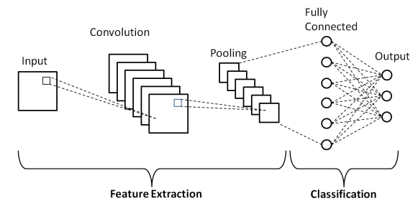

Figure 1 - 1-D CNN Diagram Schematic Representation [7]

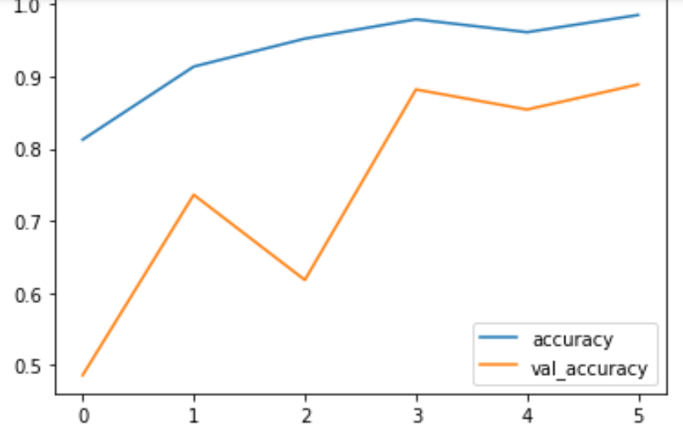

Figure 2 - Comparing accuracy and val_accuracy

Figure 3 - Comparing loss and val_loss

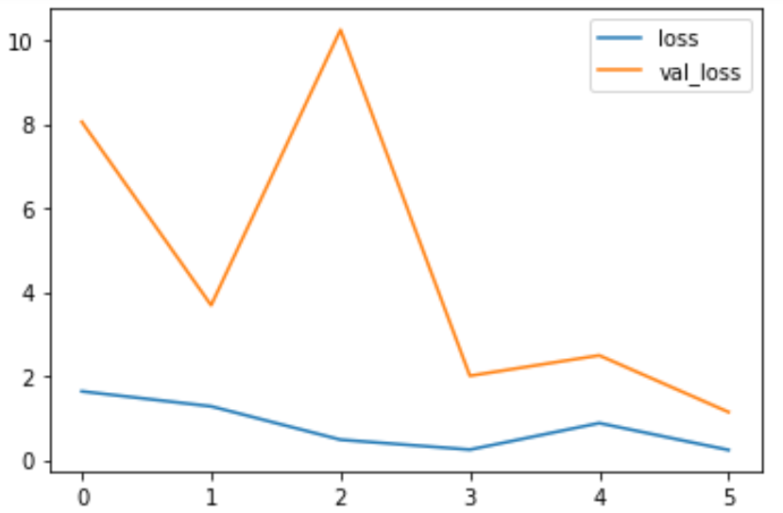

**LIST OF TABLES**

Table 1 - Confusion Matrix

|  |  |  |  |
| --- | --- | --- | --- |
|  | **Predicted C** | **Predicted N** | **Predicted R** |
| **Actual C** | 48 | 0 | 0 |
| **Actual N** | 0 | 48 | 0 |
| **Actual R** | 16 | 0 | 32 |

Table 2 - 1-D CNN Architecture

| **Type of Layer** | **Output Shape** | **Other Parameters of each layer** |
| --- | --- | --- |
| Conv1DBatch NormalizationMax Pooling 1DActivation | (11364;64)(11364;64)(5682;64)(5682;64) | Filters - 64, Kernel Size - 6, Pool Size – 3, Activation - Relu |
| Conv1DBatch NormalizationMax Pooling 1DActivation | (5682;64)(5682;64)(2841;64)(2841;64) | Filters - 64, Kernel Size - 6, Pool Size – 3, Activation - Relu |
| Conv1DBatch NormalizationMax Pooling 1DActivation | (2841;64)(2841;64)(1421;64)(1421;64) | Filters - 64, Kernel Size - 6, Pool Size – 3, Activation - Relu |
| FlattenDenseDenseOutput Layer | (90944)(64)(64)(3) | Units - 64, Activation – ReluUnits - 64, Activation – ReluUnits - 3, Activation – SoftMax |

Table 3 - RESULT

|  |  |
| --- | --- |
| **PARAMETER** | **VALUE** |
| ACCURACY | 0.8888888 |
| MIS-CLASSIFICATION | 0.1111111 |
| SENSITIVITY(RECALL) | 0.8888888 |
| SPECIFICITY | 0.9444444 |
| PRECISION | 0.9166666 |
| F_1 SCORE | 0.8857142 |

1. **RESULT AND DISCUSSION:**

The 6 parameters calculated for our classification as output are as follow:

Sensitivity tells about how many positive instances of classes are correctly classified.[8]

**Avg_RC = sum (RC) / row**

Specificity tells us about how many of the true negatives were assigned the secondary class.[8]

**Avg SP = sum (SP) / row**

Accuracy tells us about how many samples are accurately classified.[8]

**Accuracy = (sum (confusion_matrix.diagonal ()) / sum (sum (confusion_matrix)) )**

MisClassification tells us about how many samples are wrongly classified.[8]

**MisClassification = 1-Accuracy**

Precisiontells us how many are actually positive among the predicted positives.[8]

**Avg PR = sum (PR) / row**

The harmonic mean of precision and recall is defined as F-Score.[8]

**Avg F1 = sum (F1) / row**

1. **CONCLUSION:**

The classification of mental states based on their activity is evaluated using 1-Dimensional Convolutional Neural Network using python language and google colab as an online interpreter. After performing upsampling and train-test split in a ratio of 70:30. After evaluating the dataset with 1-D CNN model consisting of 3 Convolutional layers, the classification of mental states has been performed.

7**. REFERENCES:**

[1] Bird, J. J., Manso, L. J., Ribeiro, E. P., Ekárt, A., & Faria, D. R. (2018, September). A study on mental state classification using eeg-based brain-machine interface. In *2018 International Conference on Intelligent Systems (IS)* (pp. 795-800). IEEE.<http://jordanjamesbird.com/mental-state-classification-using-eeg-based-brain-machine-interface/>

[2]Tan, B. H. (2012). Using a low-cost eeg sensor to detect mental states. *IJAER*.

[3] Di Flumeri, G., Aricò, P., Borghini, G., Sciaraffa, N., Di Florio, A., & Babiloni, F. (2019). The dry revolution: evaluation of three different EEG dry electrode types in terms of signal spectral features, mental states classification and usability. *Sensors*, *19*(6), 1365.

[4] Bilgin, P., Agres, K., Robinson, N., Wai, A. A. P., & Guan, C. (2019, October). A comparative study of mental states in 2D and 3D virtual environments using EEG. In *2019 IEEE International Conference on Systems, Man and Cybernetics (SMC)* (pp. 2833-2838). IEEE.

[5] Calvo, R. A., Brown, I., & Scheding, S. (2009, December). Effect of experimental factors on the recognition of affective mental states through physiological measures. In *Australasian Joint Conference on Artificial Intelligence* (pp. 62-70). Springer, Berlin, Heidelberg.

[6] Anderson, C. W., Stolz, E. A., & Shamsunder, S. (1995, September). Discriminating mental tasks using EEG represented by AR models. In *Proceedings of 17th International Conference of the Engineering in Medicine and Biology Society* (Vol. 2, pp. 875-876). IEEE.

[7] 1-D CNN Schematic Image: <https://www.researchgate.net/figure/Schematic-diagram-of-a-basic-convolutional-neural-network-CNN-architecture-26_fig1_336805909>

[8] Maeda-Gutierrez, V., Galvan-Tejada, C. E., Zanella-Calzada, L. A., Celaya-Padilla, J. M., Galván-Tejada, J. I., Gamboa-Rosales, H., ... & Olvera-Olvera, C. A. (2020). Comparison of convolutional neural network architectures for classification of tomato plant diseases. *Applied Sciences*, *10*(4), 1245.

[9]Data is collected from**:** <https://github.com/jordan-bird/eeg-feature-generation>